Caving and challenging stereotypes

Goyden Pot: 1 April 1995

My first ever caving trip. A hearty breakfast in Pately Bridge, which I managed O.K. despite reservations about going into the toilets after some of the survivors of Dave's beer and curry, gathering the night before. Well, caving seems allright so far.
Upon arrival at Goyden, somebody asked "Are you nervous"? "No", I answered honestly, though I was quietly hoping there wouldn't be too many (any?) tight squeezes down there. After much deliberation, and consultation with two people that had just emerged from Goyden, we set off down the river into the cave entrance. Still O.K. as we left the daylight behind, then my lamp detected the soles of wellingtons disappearing into a small hole ahead. Deep breath for my first squeeze "Excuse me, we've not met before but if I panic in there just slap my face and pull me out, would you"?

I got Bernie's suit wet, partly by slithering through puddles and partly by the cold sweat of fear, but I got through. I was assured by Dave that this was the tightest bit, so I looked forward to the rest of the trip.
We got as far as the pitch before the waterway without incident and Dave said that he would take the novices back up while the more experienced/adventurous went down the hole. "I think I'll go back with you Dave", I said bravely. "Too bloody right!" said Dave.
Back through the squeeze with hardly a qualm, then down for a look at the waterfall far below us. This was the kind of sight I came for, water thundering off the ledge above us and swirling off into the dark. Then the thundering got louder and a new waterfall suddenly appeared over our heads. Through the roar, I heard somebody shout "Et ow ow", which I later translated into "GET OUT NOW!"
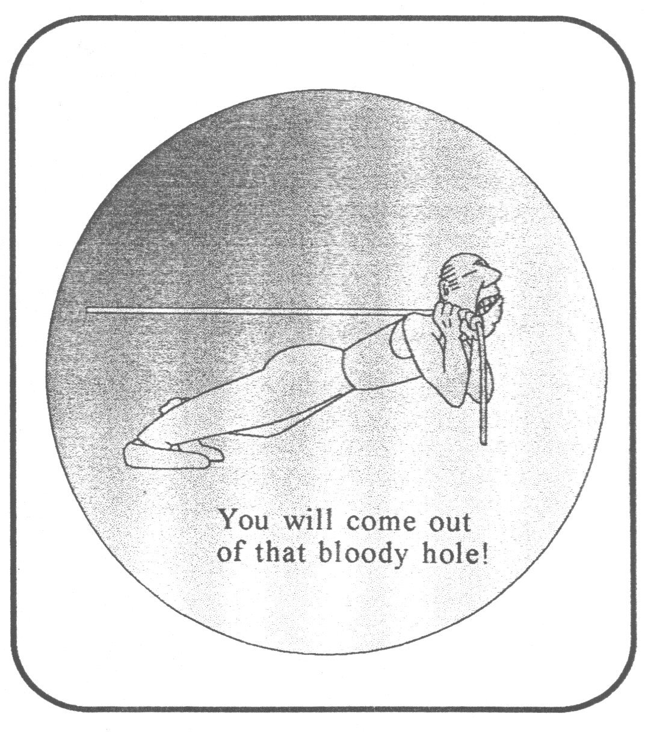

The absence of colour in the faces of those around me told me there was something wrong and we swiftly headed back up the waterway to - horror of horrors - a tiny crack in the rock which led to the 'back steps'.
Most of us were scared (I was terrified) but some were more vocal than others. Through it all, however, Dave was a model of sang - froid full of helpful advice "Control your breathing", "Get through there, you fat bastard!" I am not sure I would have made it out without that calming influence and the support and strength of Andy and Co. Which brings me to stereotypes. We all have to deal with stereotypical assumptions in our lives - some of us may even subscribe to them, though we all (hopefully) try not to. The stereotype of a potholer is a rugged, macho bore. Not on my first trip. I found them sensitive and helpful, with none of the anticipated derision of my fear or my feeble efforts to scrabble up seemingly endless rocks. I particularly want to have babies by Dave and Andy.
The stereotypical view of women is of weak and timid creatures, ready to break into fits of screaming at the slightest hint of danger. Not in Goyden, they're not. If anybody you know needs convincing about equality, bring them caving!
Thank you all. I hope you will allow me to join you again soon.

Ken Baker (The pot-bellied pot-holer (novice))

[so what happened then – please read on for alternative meets report]
…And What About That Bog Burst

A decision was made to descend the cave, waters were on the drop and the weather forecast was good. Fortunately, I decided to enter via Backsteps entrance to see if it was open, fortunately for a lucky group it was.

On planning to do the usual round trip, an inspection of the main streamway was made and reported to be inadvisable to be descended/ascended due to the group having novices in it.
After a turn-around point at mud hall the group split leaving a group to descend further into the system. A quick look at the main chamber and a group tackled the cascades to suddenly find an increase of water levels and a definite loud booming sound, spray lashed the back wall of the chamber wall. The group was led to a hasty retreat through Back Steps Entrance and great team work brought together a safe and quick exit.

To our amazement the sky was still blue with no sign of a thunderstorm, (My first thoughts after the amount of water increase in such a short spell of time).
Datums were made in the streamway to monitor the water level. A decision had to be made, if the water was going to rise at the same rate, then knowing the flood signs in Goyden then, well, I'll leave the rest to your imagination.

Fortunately, the water levels were dropping. Within 20 minutes the water was back to its level from when we set out. So when the second group emerged, the main entrance was easily negotiated. On the day the wind was blowing, the Dam was full with water being blown over, but surely this would cause water levels to rise and drop constantly.
This was a lot of water suddenly.

On talking to people, one cause could be what is known as Bog Burst, this is where an area of moor holds a lot of water over a period of time, 1 day up to a week or longer, a change in air pressure or climate etc, and the lot is released into the water table, a bit like taking the plug out of a sink. This would obviously cause a flood pulse, sudden, with no warning.

One known case of this happened in South Wales when a member of a party was swept away to his death by a flood pulse, with no rain or thunderstorm on that day, only heavy rain 2-3 days previous.

Unknown to us party revellers, it rained quite heavy Friday night, and this was evident driving back over the tops and witnessing wet springs and a quite high River Wharfe and Aire. Thankfully everyone got out OK but it just shows you when tackling such a cave in a high catchment area that not just the days forecast is required but a record of previous rainfall. Just ask a local!!!!

Andy

